**Saveetha school of engineering**

**CSA1592--Cloud Computing and Big Data analytics for web services**

**Tutorial for cloud computing -CSA1592**

**name: G.vivek**

**reg no : 192210286**

**serial no : 13**

EXP NO 1: CREATE A SIMPLE CLOUD SOFTWARE APPLICATION AND PROVIDE IT AS A SERVICE USING ANY CLOUD SERVICE PROVIDER TODEMONSTRATE SOFTWARE AS A SERVICE (SAAS).





EXP NO 2: CREATE A SIMPLE CLOUD SOFTWARE APPLICATION FOR FLIGHT RESERVATION SYSTEM USING ANY CLOUD SERVICE PROVIDER TO DEMONSTRATE SAAS.

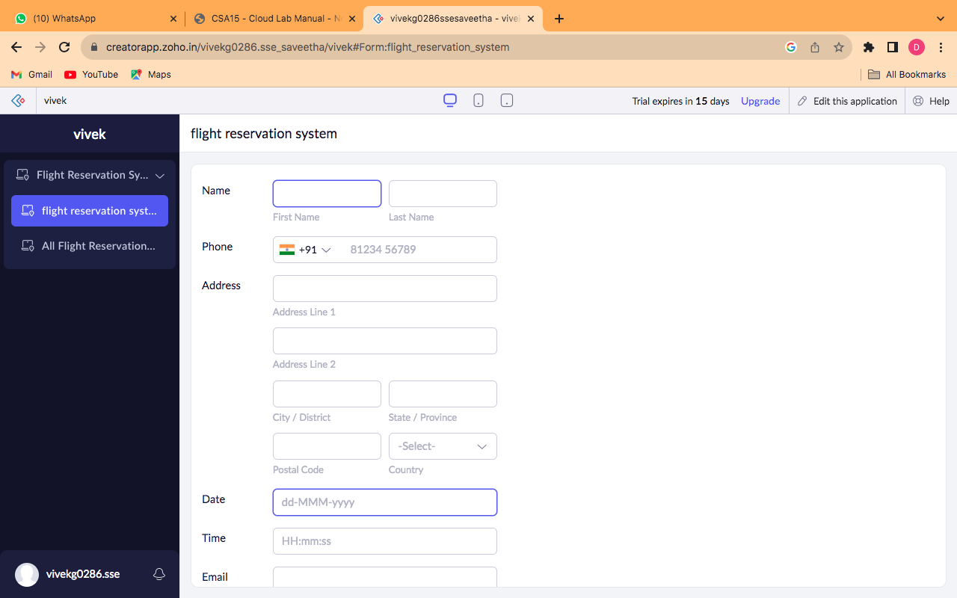

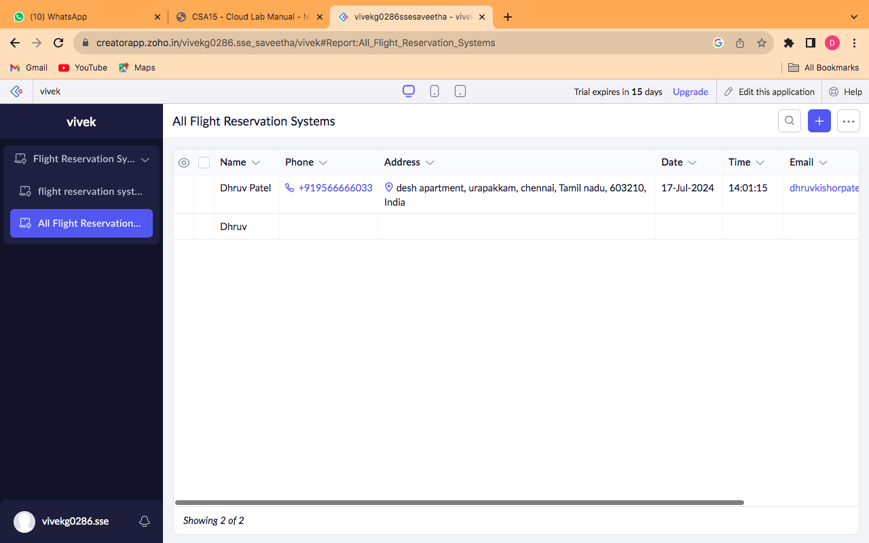

EXP NO 3: CREATE A SIMPLE CLOUD SOFTWARE APPLICATION FOR PROPERTY BUYING & RENTAL PROCESS (IN CHENNAI CITY) USING ANY CLOUD SERVICE PROVIDER TO DEMONSTRATE SAAS.

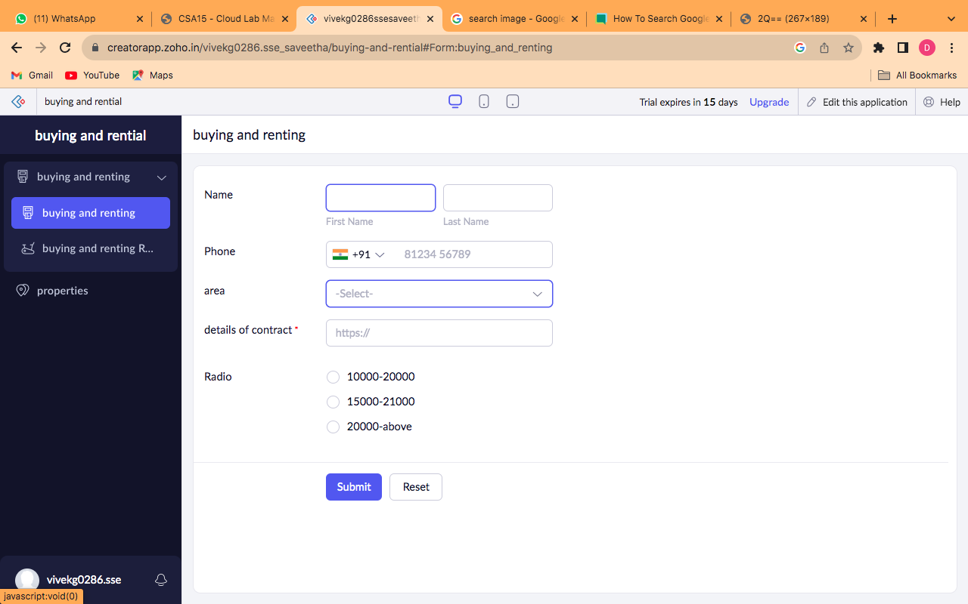

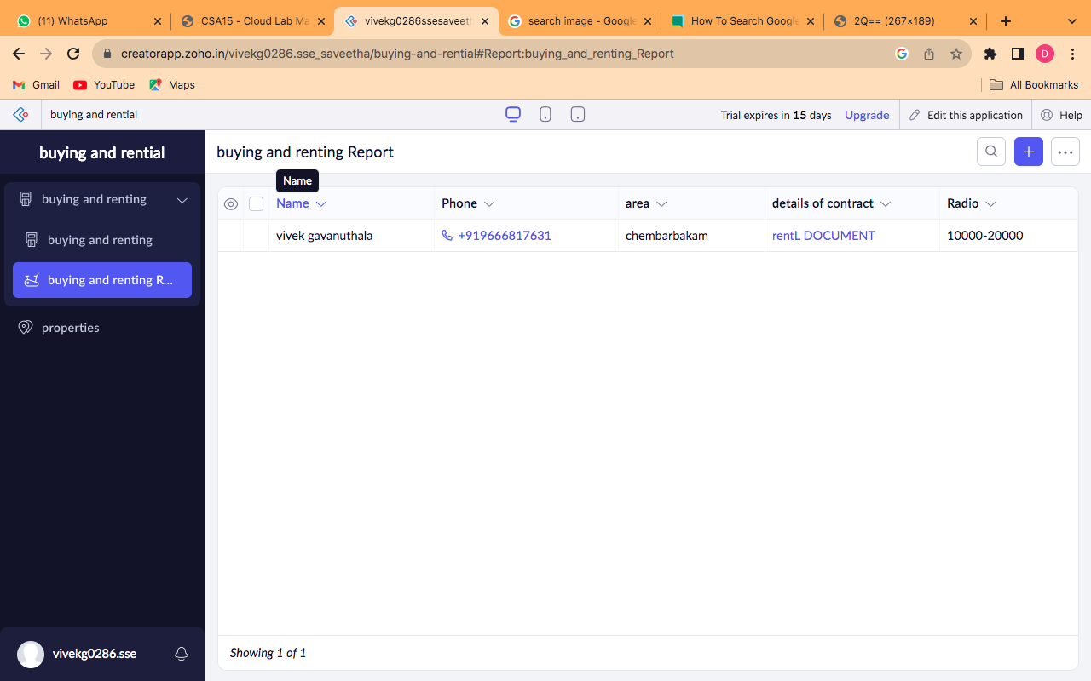

EXP NO 4: CREATE A SIMPLE CLOUD SOFTWARE APPLICATION FOR CAR BOOKING RESERVATION SYSTEM USING ANY CLOUD SERVICE PROVIDER TO DEMONSTRATE SAAS.





EXP NO 5: CREATE A SIMPLE CLOUD SOFTWARE APPLICATION FOR LIBRARY BOOK RESERVATION SYSTEM FOR SIMATS LIBRARY USING ANY CLOUD SERVICE PROVIDER TO DEMONSTRATE SAAS





EXP NO 6: CREATE A SIMPLE CLOUD SOFTWARE APPLICATION FOR PRODUCT SELLING USING ANY CLOUD SERVICE PROVIDER TO DEMONSTRATE SAAS.





EXP NO 7: DEMONSTRATE VIRTUALIZATION BY INSTALLING TYPE-2 HYPERVISOR IN YOUR DEVICE, CREATE AND CONFIGURE VM IMAGE WITH A HOST OPERATING SYSTEM (EITHER WINDOWS/LINUX).





EXPNO 8: CREATE A VIRTUAL MACHINE WITH 1 CPU, 2GB RAM AND 15GB STORAGE DISK USING A TYPE 2 VIRTUALIZATION SOFTWARE.





EXP 9: CREATE A VIRTUAL HARD DISK AND ALLOCATE THE STORAGEUSING VM WARE WORKSTATION.



EXPNO 10: CREATE A SNAPSHOT OF A VM AND TEST IT BY LOADING THE PREVIOUS VERSION/CLONED VM



EXPNO 11: CREATE A CLONING OF A VM AND TEST IT BY LOADING THE PREVIOUS VERSION/CLONED VM.





EXP 12: CHANGE HARDWARE COMPATIBILITY OF A VM (EITHER BY CLONE/CREATE NEW ONE) WHICH IS ALREADY CREATED AND CONFIGURED.



EXP13. DEMONSTRATE INFRASTRUCTURE AS A SERVICE (IAAS) BY CREATING A VIRTUAL MACHINE USING A PUBLIC CLOUD SERVICE PROVIDER (AZURE), CONFIGURE WITH REQUIRED MEMORY AND CPU.





EXP 14 .DEMONSTRATE INFRASTRUCTURE AS A SERVICE(IAAS) BY CREATING AVIRTUAL MACHINE USING A PUBLIC CLOUD SERVICE PROVIDER(AZURE/GCP/AWS) CONFIGURE WITH MINIMUM CPU, RAM ANDSTORAGE AND LAUNCH THE VM IMAGE.





EXP15.CREATE A SIMPLE WEB SITE USING ANY PUBLIC CLOUD SERVICE PROVIDER (AZURE/GCP/AWS) AND CHECK THE PUBLIC ACCESSIBILITY OFTHE STORED FILE TO DEMONSTRATE STORAGE AS A SERVICE





EXP 16.DEMONSTRATE INFRASTRUCTURE AS A SERVICE(IAAS) BY CREATING AVIRTUAL MACHINE USING A PUBLIC CLOUD SERVICE PROVIDER(AZURE/GCP/AWS) CONFIGURE WITH MINIMUM CPU, RAM ANDSTORAGE AND LAUNCH THE VM IMAGE.





EXP17.CREATE A STORAGE SERVICE USING ANY PUBLIC CLOUD SERVICE PROVIDER (AZURE/GCP/AWS) AND CHECK THE PUBLIC ACCESSIBILITY OFTHE STORED FILE TO DEMONSTRATE STORAGE AS A SERVICE.





EXP18.CREATE A SQL STORAGE SERVICE AND PERFORM A BASIC QUERY USINGANY PUBLIC CLOUD SERVICE PROVIDER (AZURE/GCP/AWS) TO DEMONSTRATE DATABASE AS A SERVICE





EXP. 19: PERFORM THE BASIC CONFIGURATION SETUP FOR INSTALLINGHADOOP 2.X LIKE CREATING THE HDUSER AND SSH LOCALHOST





EXP. 20: INSTALL HADOOP 2.X AND CONFIGURE THE NAME NODE AND DATANODE.





EXP. 15: LAUNCH THE HADOOP 2.X AND PERFORM MAPREDUCE PROGRAMFOR A WORD COUNT PROBLEM



